CSMIO-MPG
manual pulse generator
JOG module
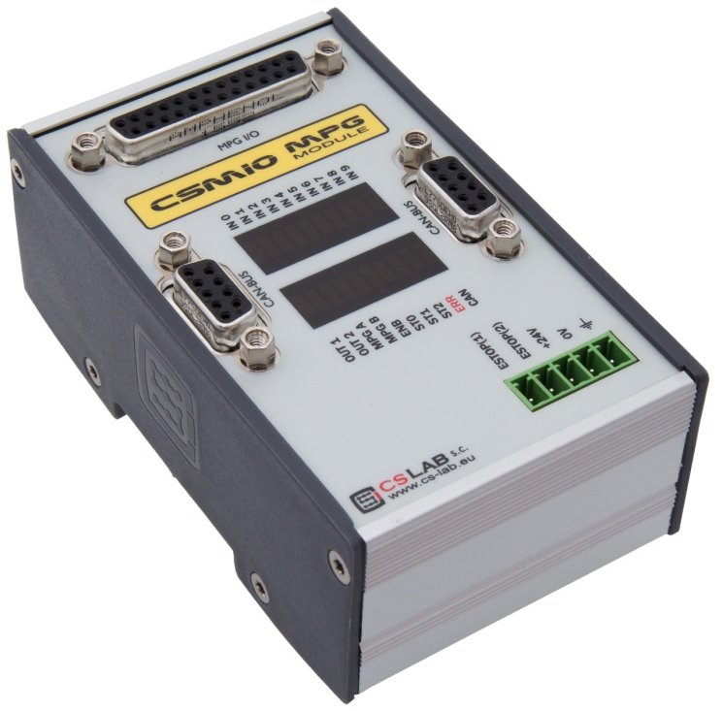

CONTENT
1. General information 3
1.1 Signs used in this guide 3
1.2 Standards compliance 4
1.3 Technical data 4
1.4 Changes regarding to previous version of CSMIO-MPG module 5
2. Safety 6
3. Recommendations for mechanical installation 7
4. Connectors 8
4.1 Connector arrangement 8
4.2 DB25 Connector. 9
4.3 Connector for CSMIO/IP (or previous module connection) 10
4.4 Connector for next expansion modules connection 10
4.5 Power supply connector 11
5. CSMIO-MPG module configuration 11
5.1 Termination of CAN bus and RS485 11
5.1.1 External terminator 12
5.1.2 CSMIO-MPG module view with terminator plugged in. 12
6. Handwheel MPG connection scheme 13
6.1 Handwheel MPG with differential encoder output 13
6.2 Handwheel MPG with common encoder output. 14
7. Mach3 configuration 15
7.1 Multiplier range selection. 16

General information

The CSMIO-MPG module is used to provide the 6-axis CSMIO/IP series controllers with a manual pulse generation (MPG) function. The CSMIO-MPG is a separate module designed to connect it to the CSMIO/IP controller via the CAN bus.

By using the manual pulse generator, it is possible to manually control a maximum of 6 axes precisely without using the MACH3 program.

Like the CSMIO/IP, the CSMIO-MPG requires 24VDC power. Digital inputs and outputs are optically isolated and filtered. In the v2 version of the module also encoder inputs have an optical isolation.

The CSMIO-MPG is enclosed in a compact enclosure designed for DIN-rail mounting. This makes mechanical and electronic installation in a control cabinet much simpler.

The manual pulse generation module is equipped with 3 digital inputs of multiplier selection (x1, x10, x100), 6 digital inputs of controlled axis selection, 1 digital input for general purposes, 2 analog inputs, 2 digital outputs for general purposes and E-STOP circuit.

The manual handwheel encoder compatible with CSMIO-MPG module is available separately in CS-Lab online store.

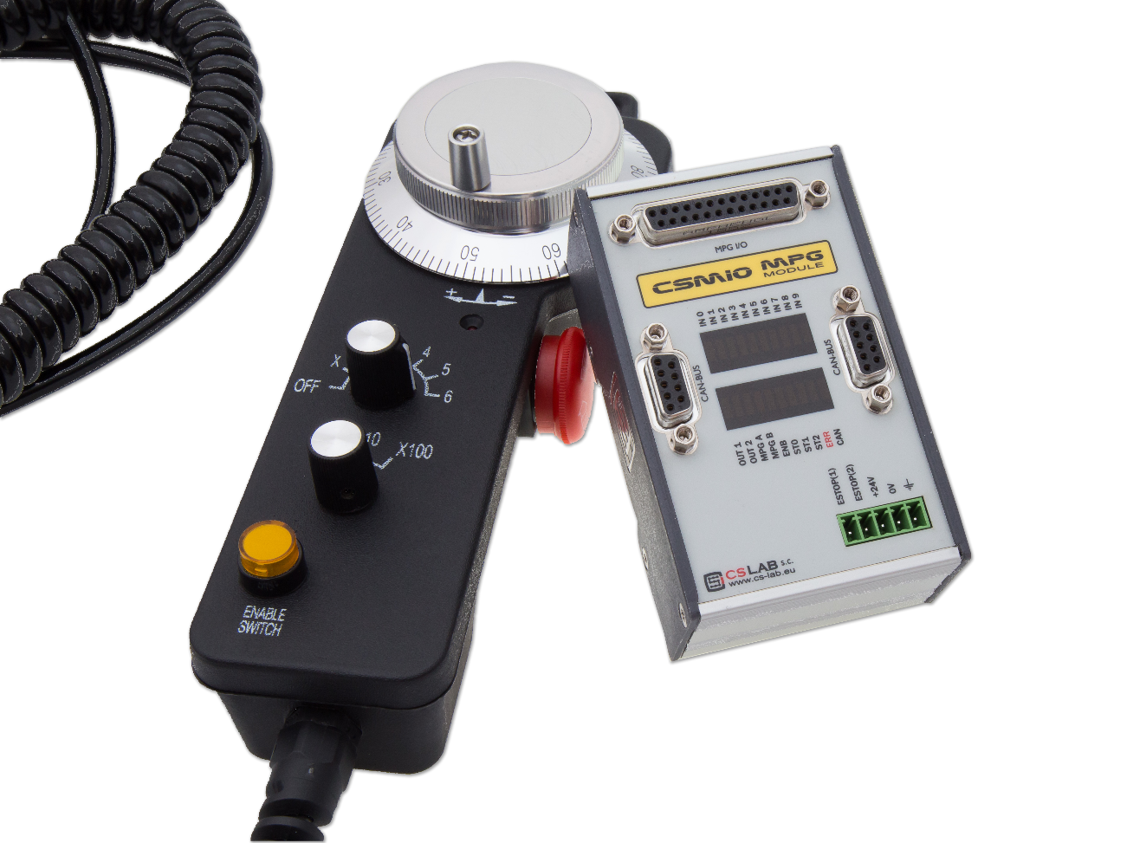

Signs used in this guide

Potential danger, possible risk of injury.
Useful information, tips
Warning, failure to comply with these warnings may lead to inappropriate functioning or damage to the device

Content of the package

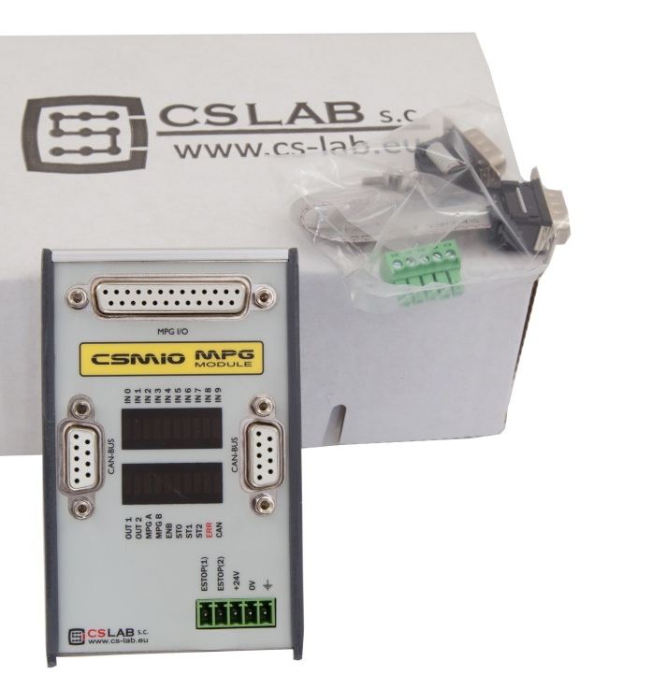

Standards compliance
CSMIO-MPG modules were designed and made in accordance with the national and international standards for industrial control systems based on electronic components:
- Detailed requirements for programmable controllers: working characteristics, shock resistance, safety etc. EN61131-2 (IEC1131-2), CSA 22.2, UL508
- Compliance with European Guidelines (low voltage, the level of electromagnetic interference Electromagnetic Compatibility), the CE marking.
- Electrical and non-combustible properties of insulation materials: UL 746C, UL 94, etc.
- The Product made in lead-free technology; RoHS compliant.

Technical data

PARAMETER | VALUE
Digital inputs | 10
Digital outputs | 2
Analog inputs | 2
Analog outputs | 0
Supply voltage | 24VDC +/-10%
Power consumption | 2W
Maximum I/O voltage | 30VDC
Maximum I/O load | 30mA
Analog Input Voltage | 0-5 VDC
Rotary Encoder input | TTL 5V (±A/±B)
Connection with CSMIO/IP | CAN 250kbps
Ambient temperature range | 0ºC do +60ºC
Relative humidity (Non-condensing) | 10% - 95%
Encoder inputs (±A/±B) allow connection to different styles of rotary encoders. See chapter 5 for more information.

Changes regarding to previous version of CSMIO-MPG module

The main change regarding to the previous version is lack of configuration switches. The change is due to implementation of optical isolation on inputs of a handwheel encoder. This way we get higher resistance to interferences, especially when the handwheel we use has no differential outputs. In this situation we need line polarization when we use handwheels without the differential outputs. On the configuration jumpers there was also a switch responsible for CAN bus termination. Currently there is a terminator included which should be plugged in if the module is the last device on the CAN bus. If we have only CSMIO-MPG module connected to the CAN bus, then we plug in the terminator on right DB9 connector.

Safety

The CSMIO-MPG device is powered by 24VDC low voltage. I / O control lines are optically isolated, and the PC connection is galvanically isolated. The device does not constitute a direct threat to the health or life of the user.
When designing a complete control system, you should draw attention to all issues, so that the entire system does not pose any hazard during use.
Pay special attention to the emergency stop circuit. The control system must be designed in such a way that when you press the emergency stop mushroom, the controlled machine immediately stops all axes. You should also consider the possible failure of any system components such as the main controller, or axis drives.

Recommendations for mechanical installation

Here is an example - components arrangement in the control cabinet.
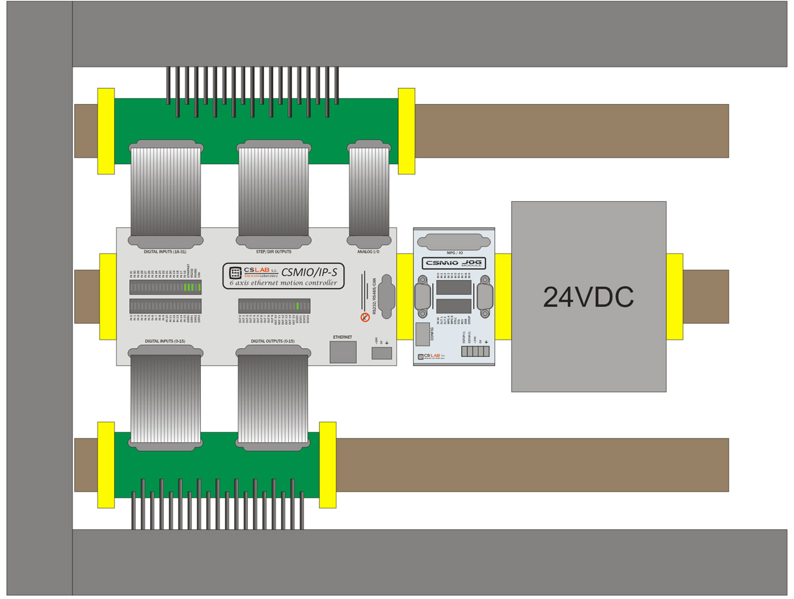

Caution is advised during the mechanical and electrical installation. Poorly tightened cables may cause many problems; it’s also very difficult to find such a defect while launching/using the system.

Connectors

Connector arrangement

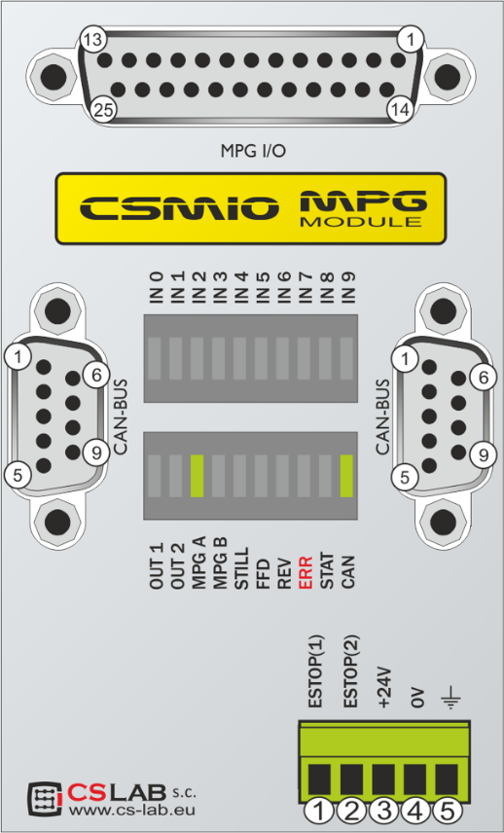
MPG handwheel connector

Connector for
CSMIO-IP or previous module

Connector for next expansion modules or CAN terminator/ RS485

Power supply connector
+
Safety circuit

DB25 Connector.
PIN number | Description
1 | 24VDC output (250mA)
2 | Digital output 0
3 | 5VDC output (250mA)
4 | A- (TTL 5V) input
5 | B- (TTL 5V) input
6 | Analog input 1 (0-5V)
7 | Digital input 0 (x1)
8 | Digital input 2 (x100)
9 | Digital input 4 (Y axis)
10 | Digital input 6 (A axis)
11 | Digital input 8 (C axis)
12 | Shared power supply (-)  for 0÷9 inputs
13 | E-Stop 2
14 | GND
15 | Digital output 1
16 | A+ (TTL 5V) input
17 | B+ (TTL 5V) input
18 | Analog input 0 (0-5V)
19 | GND
20 | Digital input 1 (x10)
21 | Digital input 3 (X axis)
22 | Digital input 5 (Z axis)
23 | Digital input 7 (B axis)
24 | Digital input 9
25 | E-Stop 1
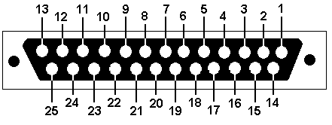

Max. allowed load of 250mA/pin of the 5V and 24V connector power.

The outputs have 50mA load. Do not overload outputs. You should also pay attention, if large inductances are connected, you may need to use an additional surge diode, preferably as close to the coil as possible.

Connector for CSMIO/IP (or previous module connection)
PIN | Description
1 | CAN H
2 | -
3 | -
4 | -
5 | GND
6 | CAN L
7 | RS485 B-
8 | RS485 A+
9 | -

For proper module operation CAN H, CAN L, and GND must be connected to the CSMIO module. Connections RS485 B- and RS485A+ are used in other CSMIO modules and their connection may be required for proper operation.

Connector for next expansion modules connection
PIN | Description
1 | CAN H
2 | RS232 RxD
3 | RS232 TxD
4 | -
5 | GND
6 | CAN L
7 | RS485 B-
8 | RS485 A+
9 | -
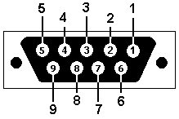

This connector is dedicated only for CS-Lab expansion modules. Do not connect any other devices, PC, etc.

Power supply connector
PIN | Description
1 | E-Stop 1
2 | E-Stop 2
3 | power + 24V DC
4 | GND
5 | ground

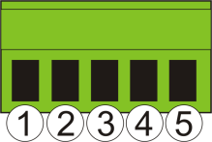

Widok wtyczki od strony przyłączenia przewodów
Pay special attention to not exceed the permissible power voltage (30VDC). This can damage the device.

CSMIO-MPG module configuration
CSMIO-MPG module version V2 does not require any configuration. However, there are some differences in connection way - it depends on whether handwheel encoder outputs are common or differential. Both connection ways were shown in next chapter.

Termination of CAN bus and RS485
Some expansion modulef from CSMIO devices family have termination switch of CAN bus and RS485. CSMIO-MPG v2 module does not have any configuration switches and due to that it is required to plug in a special Terminator if CSMIO-MPG v2 is the only or last module in line.
For example:
- CSMIO/IP-x CSMIO-IO CSMIO-ENC CSMIO-MPG (external terminator)
- CSMIO/IP-x CSMIO-MPG (external terminator)
- CSMIO/IP-x CSMIO-MPG CSMIO-IO (termination switched on in CSMIO-IO module)

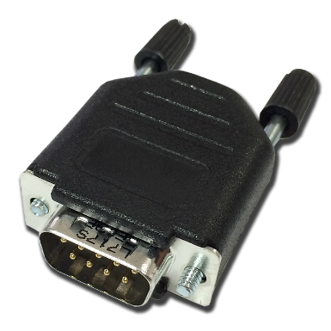
External terminator

CSMIO-MPG module view with terminator plugged in.

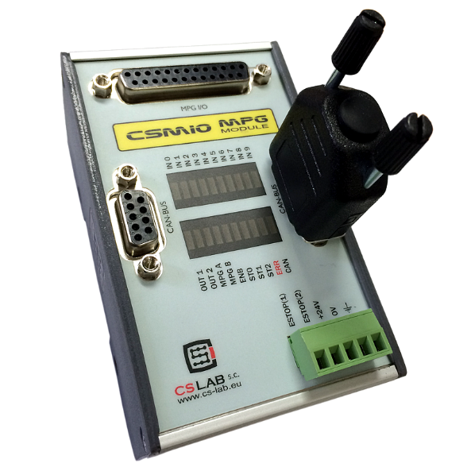

Handwheel MPG connection scheme

Handwheel MPG with differential encoder output

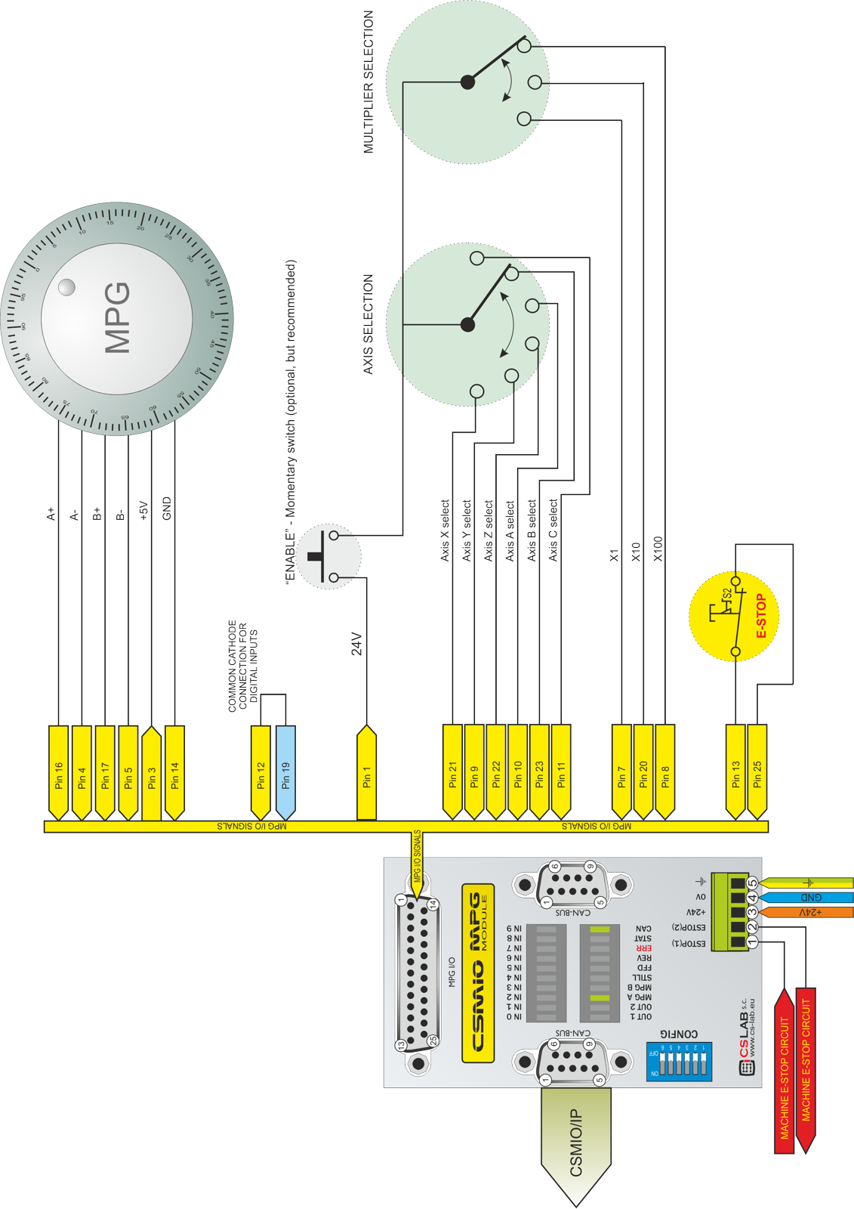

Handwheel MPG with common encoder output.
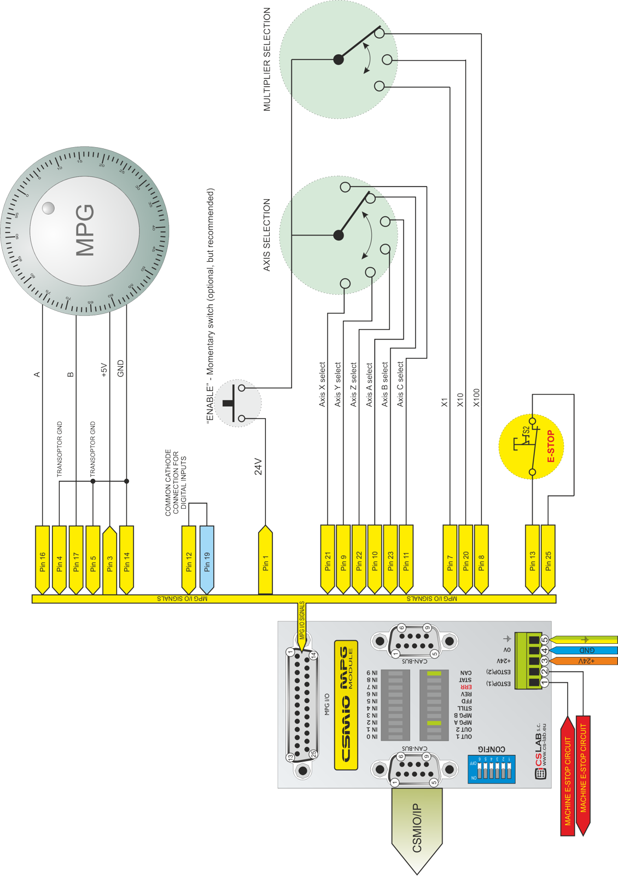

Mach3 configuration

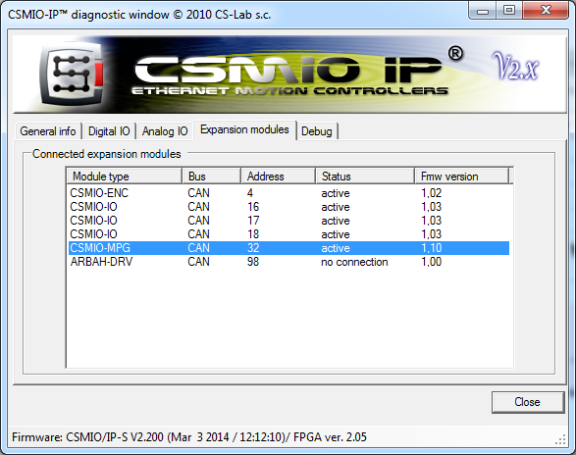
One of advantages of the CSMIO-MPG module is that you almost do not need to configure it.

- After CSMIO/IP-S controller connection you should turn the power on and launch Mach3 program.
- In the “PlugIn Control” menu choose “CSMIO-IP-P_plugin”
- In the diagnostic window go to the “Expansion modules” tab.

If connections are correct, the CSMIO-MPG module should appear on the list of modules detected by our controller.

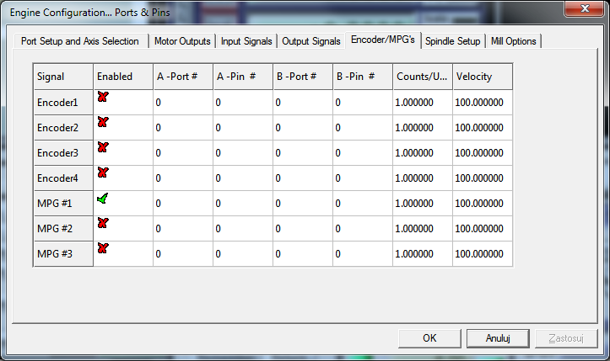
Next – in the Mach3 program- turn on the MPG function. To do this – click on the “Config/Ports and Pins” and go to the “Encoder/MPG’s” tab and select MPG#1.

From now on the module is ready to work.

Multiplier range selection.

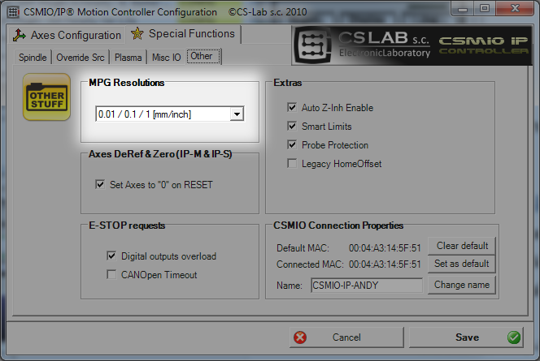
The basic assumed distance unit is 1/10000 of a Mach3 unit, namely 1/1000mm (1um) or 1/10000 inch depending on used unit imperial or metric.
The CSMIO-MPG module has three inputs of multiplier selection. It is possible to choose if these inputs switch the resolution between:

- 0.0001 / 0.001 / 0.01 of the unit
- 0.001 / 0.01 / 0.1 of the unit
or
- 0.01 / 0.1 / 1.0 of the unit

You can select it in the plugin’s configuration - “Config/Config Plugins” menu, click “CONFIG” area, next to the CSMIO-IP-P-CS-Lab-s.c.” and go to "Other" tab. In the “MPG Resolutions” group select the desired multipliers.

